Task 1:

Create a Directory with the Name Linux Practice.

Task2:

Change to the directory



Task 3:

Create a file names TestFile1.txt and add the content to it.

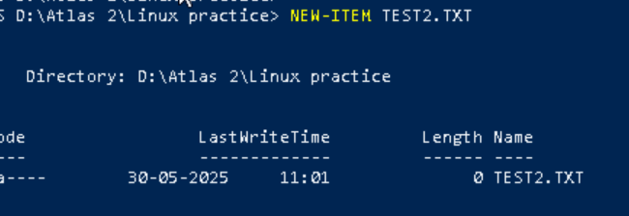

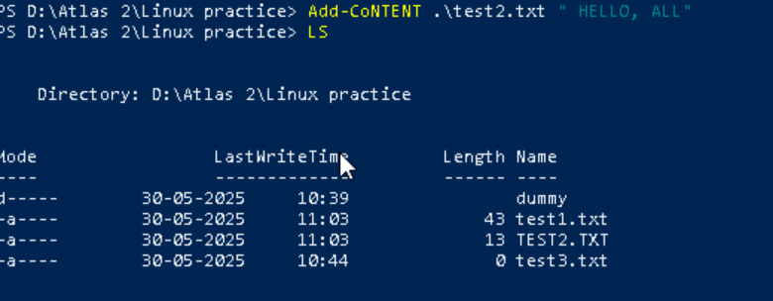

Task 4:

Create a Folder named Dummy and try to delete it.

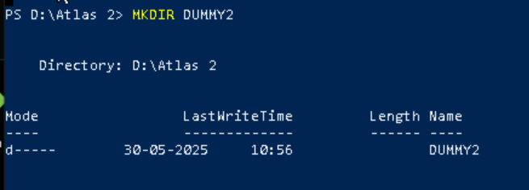

REMOVING THE DIRECTORY--DUMMY

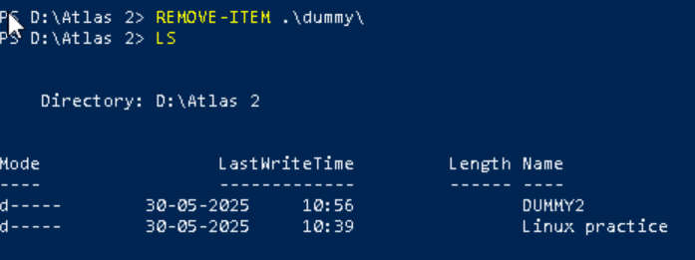

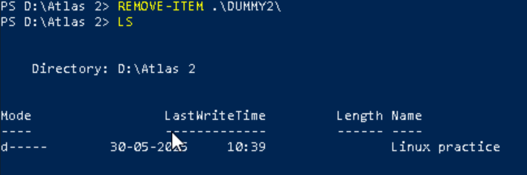

Task 5:

Plz check the working directory (Hint : pwd)

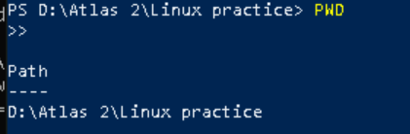

Task 6:

How do you check all the files and directories in the directory you are in?

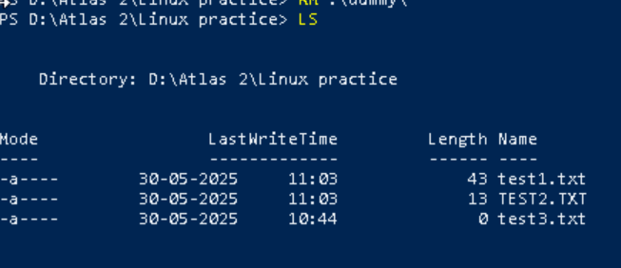

Task 7:

Create five files named TestFile8.txt.. TestFile9.txt… and so on till TestFile6.txt

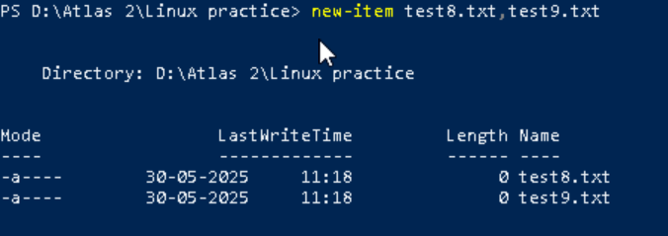

Task 8:

Copy all files from Dir 1 ti Dir 2

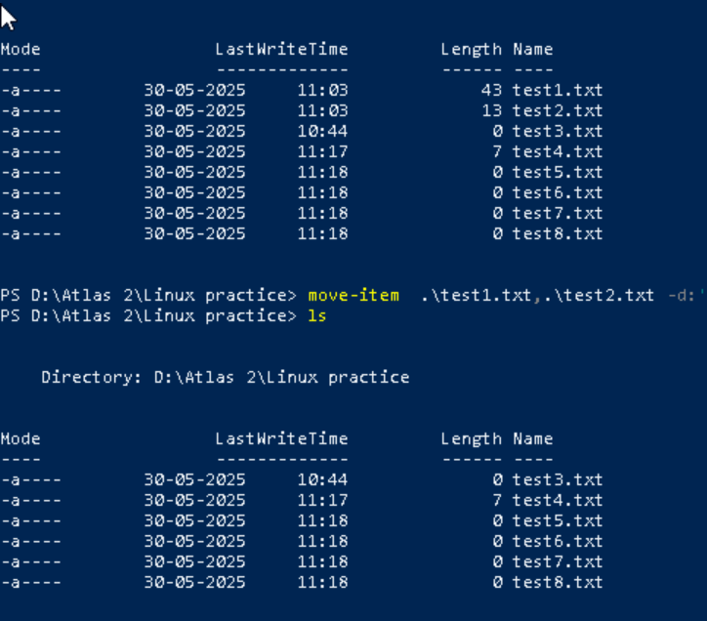

After moved:

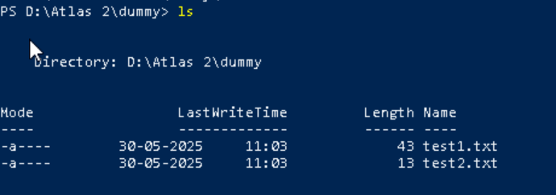

Task 10:

Can you plz show me the diff between **rm** and **rmdir** commands with screen shots ?

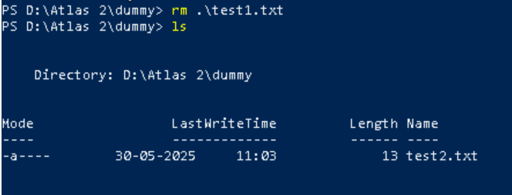

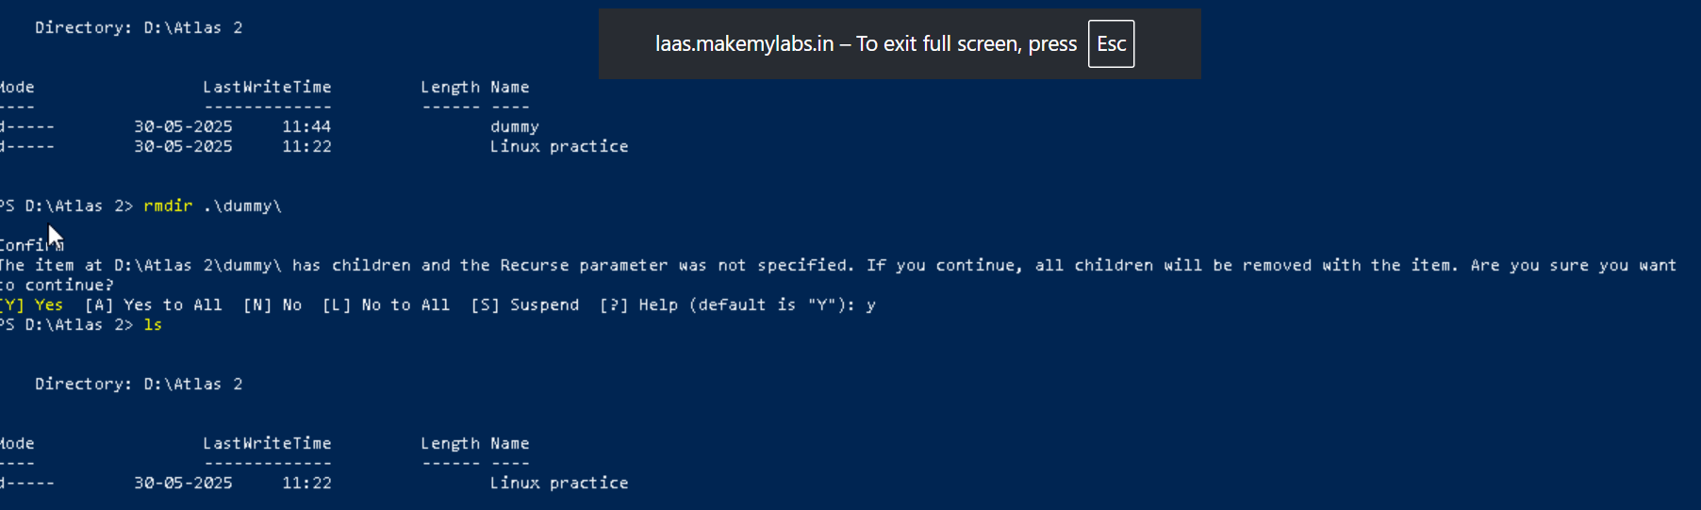

Ok now open Lorem Ipsum in your browser

<https://www.lipsum.com/>  u can use this link for random text..

Task 11:

Now use specifically use cat command to create a file

And add the dummy text of 2 to 3 paragraphs from the above link Lorem Ipsum.

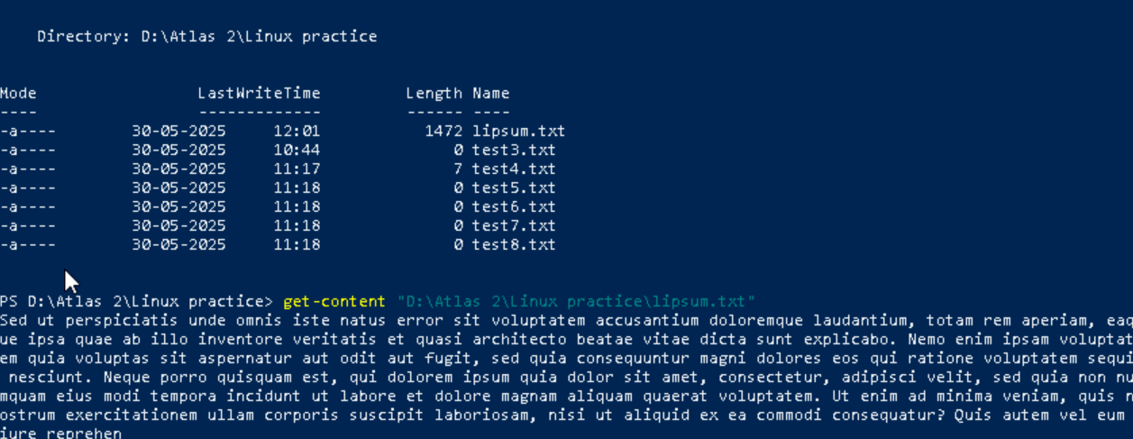

Task 12:

How to get only the top part of your file..

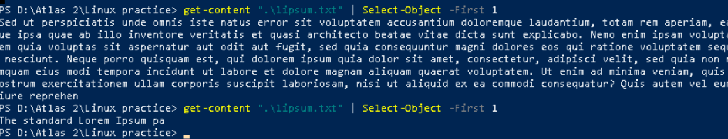

Task 13:

How to get only the last part of your file

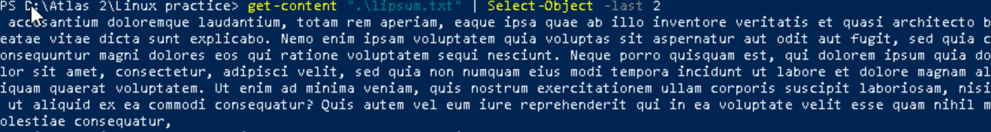

Task 14:

Plz add dummy text of 5 to 6 pages in to the same file

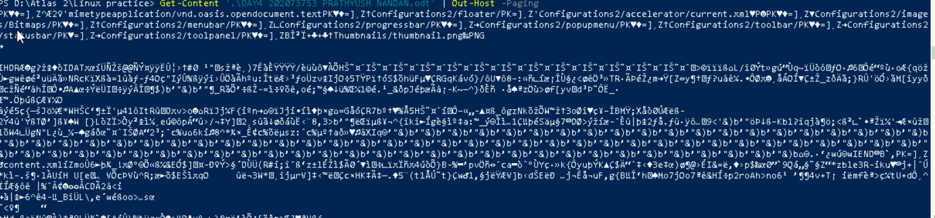

Task 15:

Use more command on the above file and find out the diff between less command and more command.

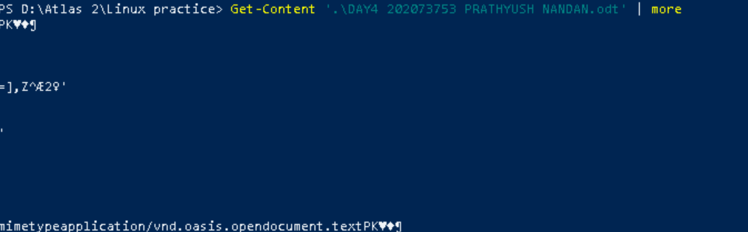

Task 16:

Can you use echo command with -e and see the diff.. Also take a ss and paste .

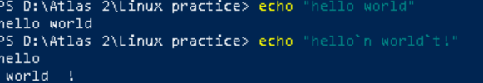

Also write the difference between touch , cat and echo commands.

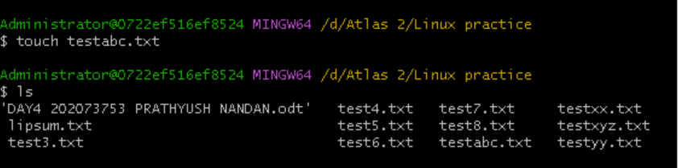

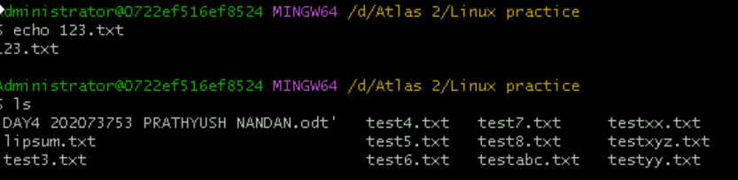

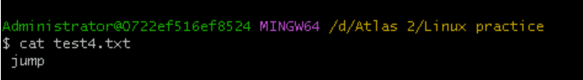

Cat - It stands for “concatenate” and is primarily used to read, display, and concatenate text files

Touch - touch is a shell command that **sets the modification timestamp of an existing file to be current**

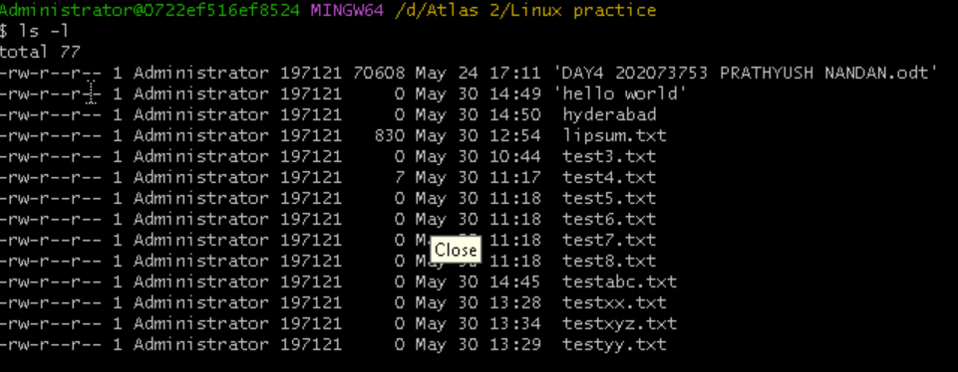



Task 20:

Can you go back to 1 directory .. at a time  whats the command



Task 21:

How to know whose user u are working on ?

Hint: use whoami command



Task 22:

Try to find out who is peeping into your system..

Hint: Use users, who and w commands with ss

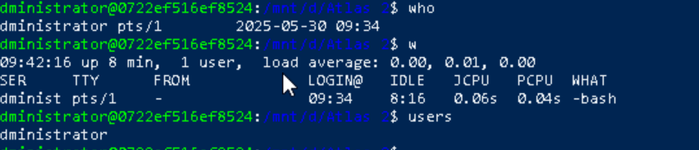

Task 23:

Can you guys try to check how much disk space is consumed..

Hint : use df -h

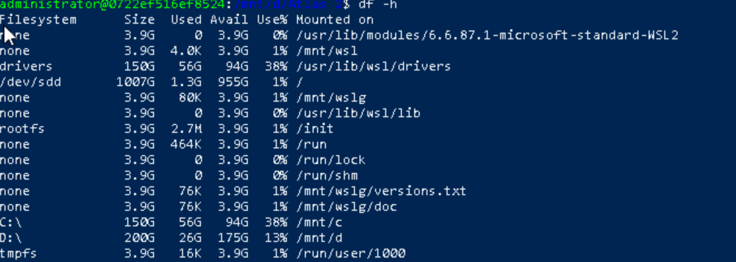

Task 24:

In the **ls -l** listing example, every file line begins with a **d**, **-**, or **l**. These characters indicate the type of the file that's listed.

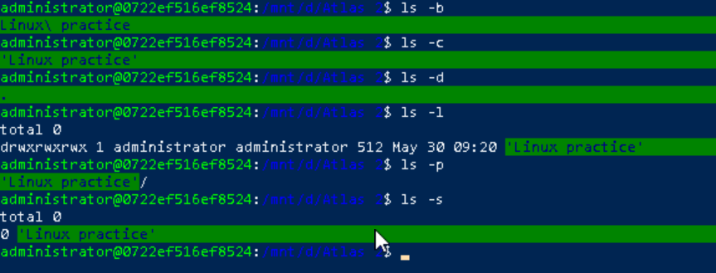

Task 25:

Find the list pf all files ending with .txt



Task 26:

In Linux all the hidden files starts with . (period)

How to check all the hidden files in Linux..

Task 27:

What is the difference between . and .. in linux

Line 1 line for each

. is current directory

.. is link to parent directory

Task 28:

Can you create a file using vi editor and show the details in ss

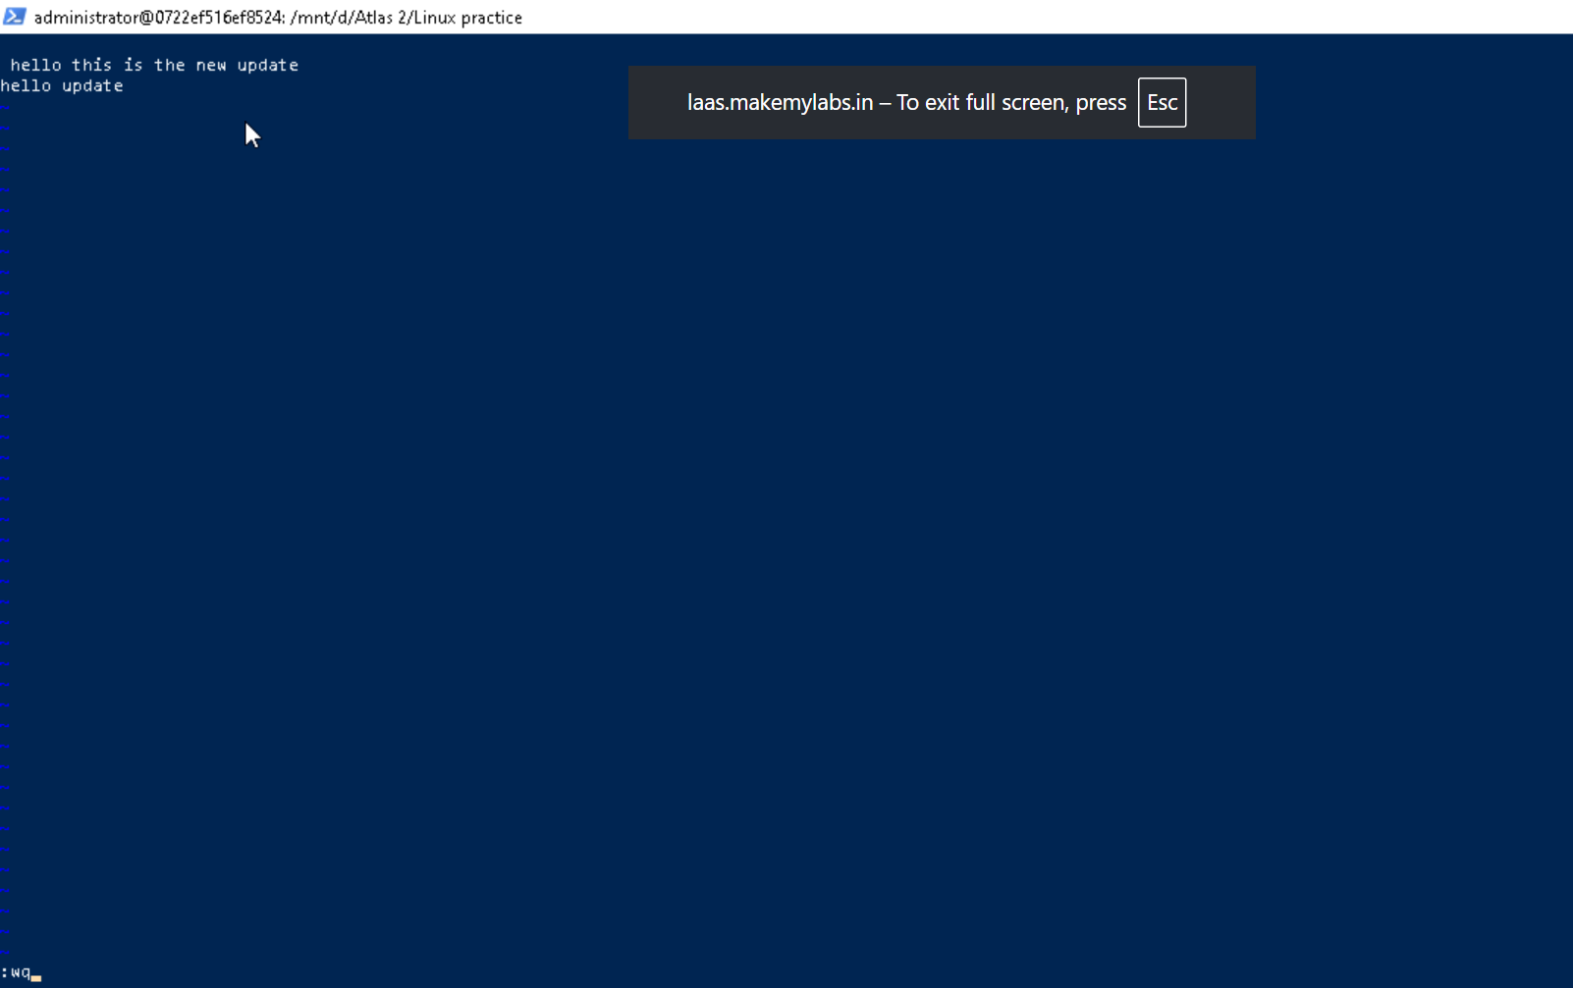

Task 29:

How to find the no of words in the file



Task 30:

What is the use of cat -b myfilename.txt command?



Task 31:

Can I use the wc with 2 or more files?



Task 32:

How to copy content of one file to another file

Hint: use cp:



Task 33:

Now I want to rename my file with MYFILENEW can i do that if so how ?

Hint use : mv

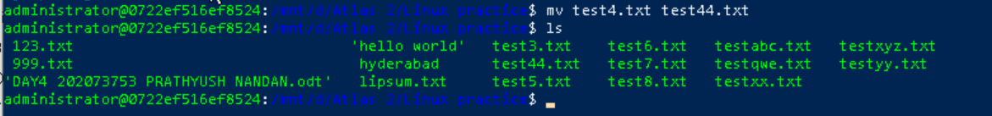

Task 34:

Can i remove or delete multiple files in linux..? How?



Task 35:

In directory / slash is root  …  can you try cd / what is it doing?

Redirects to toplevel directoryd:



Task 36:

What is the way go go to home directory ?



Task 37:

If i want to move to different users home directory